**2016-17 Board Of Directors (*理事会*) Biography**

**President:** **Lan Saadatnejadi (茹蘭)**

**Lan Saadatnejadi** has more than 20 years of experience indelivering infrastructure improvement programs and projects with innovation and ingenuity, including alternative deliveries. She has worked in both public and private sectors and understands what it takes to build a program as well as develop a project from inception through completion. She has comprehensive knowledge of federal, state, regional, and local transportation programs, including high occupancy toll (HOT) lanes, toll roads, high occupancy vehicle (HOV) lanes, freeway widening, new freeways, interchanges, multi-purpose corridors, operational improvements, etc. Throughout her

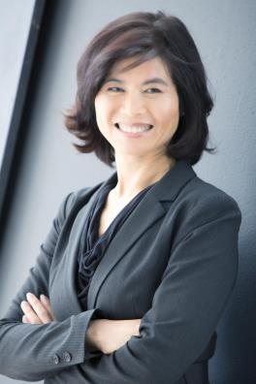

career, she has demonstrated the ability to take on challenges, bring new initiatives to fruition, build new program and project teams, and elevate teams to the next level. During her tenure with Los Angeles County Metropolitan Transportation Authority as the Executive Officer of Highway Program, she built a brand new team and developed a $20 billion Measure R Highway Program. She transformed a brand new team from grant administration to project delivery focused, and achieved an annual growth rate of 30% in project delivery. She partnered with California State University Northridge (CSUN) to de velop a series of P3 courses focusing on transportation improvement projects and has received many accolades. This is one of the strategic efforts to build broader resource pool of talents for the upcoming P3 opportunities. She founded the LRS Program Delivery, Inc. in 2014 specifically focusing on developing infrastructure projects with public-private partnership approach.

Ms. Saadatnejadi is a licensed civil engineer. She earned her bachelor’s degree in civil engineering from the University of California, Los Angeles (UCLA); and MBA from California State University, Long Beach (CSLB).

**Chainman: Yue Rong, Ph.D. *（*容躍*）***

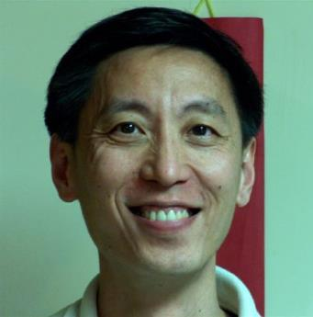

Dr. Yue Rong (a.k.a. “Y.R.”) is currently the environmental program manager at the California Regional Water Quality Control Board, Los Angeles Region. He has more than 25-year experience with the Agency in dealing with groundwater contamination problems in the Los Angeles area of California, U.S.A. He was the recipient of the California Regional Water Quality Control Board Outstanding Achievement Award and Supervisory Performance Award. He also received 2011 AEHS Foundation Achievement Award. Dr. Rong was elected in 2006 and re-elected in 2008 as the president of the Southern California Chinese American Environmental Protection Association (SCCAEPA), serving the local minority community. He has been involved with CESASC in many capacities as speaker, moderator, panelist, and annual meeting technical session chair (2013). In 2015, he was elected as the president of CESASC.

Dr. Rong is an Associate Editor for the peer-reviewed journal of *Soil and* *Sediment Contamination* and an Associate Editor for the Journal of *Environmental Forensics*. Dr. Rong is the author or co -authors for about 30peer-reviewed publications, and the Editor of the book entitled “Practical

Environmental Statistics and Data Analysis.” He is also the Editor -in-Chief for the peer-reviewed SCCAEPA Online Journal. Dr. Yue Rong has his Ph.D. in Environmental Health Sciences from the University of California at Los Angeles (UCLA), M.S. in Environmental Sciences from the University of Wisconsin, and B.S. in Earth Science from Beijing Normal University.

**Manwai Szeto *（*司徒文偉*）***

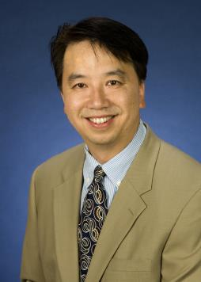

Manwai Szeto is Finance Manager for the Information Technology department at Raytheon Company, Space & Airborne Systems, in El Segundo. Mr. Szeto has been with Raytheon/Hughes Aircraft Company for over 20 years gaining experience in business & project management, accounting, operations, marketing, contracts and finance. Prior to joining the Raytheon Company, Mr. Szeto was an Industrial Engineer with Lockheed Aeronautical Systems Company in Burbank, California.

In addition to his assignment at Raytheon, Mr. Szeto has been an advocate for the Asian-Pacific community for the past 20 years. He has volunteered numerous hours mentoring young adults at the Pacific Asian Counseling Services and has also served as Vice-President and Treasurer for the Raytheon Asian Pacific Association (RAPA) and the Raytheon Management Club (RMC).

Mr. Szeto received his Bachelor of Arts degree in Economics fro m the University of California at Los Angeles (UCLA) and his Executive MBA degree at Loyola Marymount University.

**Dongmei Huang (黄冬梅)**

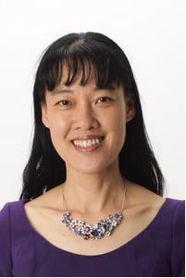

Dongmei Huang has been working at AT&T for over 15 years. Currently she is a Lead Product Marketing Manager in the area of integrated advertising platform. Dongmei had many years of IT development and ma nagement experience prior to working in product marketing.

Dongmei Huang graduated from Tsinghua University with Bachelor and Master degrees in Electronic Engineering.

Dongmei Huang has been serving the community for many years. She was elected in 2012 and re-elected in 2013 as the President of Tsinghua University Alumni Association of Southern California. Dongmei was also 2012-2013 President of Chinese Parents Club, Foothills Middle School.

**Yutao He, Ph.D. *（*何宇滔*）***

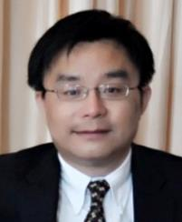

Dr. Yutao He is currently a Senior Technologist at NASA/Jet Propulsion Laboratory (JPL) leading research in innovative avionics technology for current/future space exploration missions. He has won one NASA Group Achievement Award, 4 NASA New Technology awards, a pending patent, and numerous JPL institutional awards.

Dr. He is an adjunct faculty member at UCLA and CSU-LA, and an Executive-in-Residence of College of ECST at CSU-LA. He has been serving as reviewers for numerous professional journals and conferences and as organizers of technical conferences, and on the review boards of NASA AIST and SBIR proposals in the area of avionics and information technology.

Dr. He is currently co-founder/President of LEAP Career Development Forum, a non-profit organization dedicated to career development and professional growth of Asian Americans. He is also Chair of JPL Asian American Council (AAC), Vice President of Tsinghua University Alumni Association of Southern California (THUAA-SC), and member of Chinese Engineers and Scientists Association of Southern California (CESASC) Board of Directors. He was former President of JPL/Caltech Toastmaster Club, and 2012-2014 CESASC President and Chairman. During his presidency, CESASC initiated STEM Essay Contest for middle/high school students and LEAP program for college students/junior professional.

At JPL, Dr. He has mentored over 45 high school & college interns from Caltech, UCLA, USC, UC Berkeley, UCI, Stanford, U. of Hawaii, MIT, Harvard, Princeton, Yale, Harvey Mudd Collage, etc. Some are currently working full -time at JPL, Broadcom, SpaceX, TI, Oracle, Lockheed Martin, WalmartLabs, Facebook,

CERN, etc. Since November 2011, he has been “Coach Yutao” in Science

Olympiad Team of Dana Middle School in Arcadia, California. He was a Grand Award judge in Computer Science Category at the 2014 Intel International Science and Engineering Fair (ISEF) and has been LA Science Fair judge for several years.

Dr. He holds a Ph.D. in Computer Science from UCLA and a B.S. in Electrical Engineering from Tsinghua University in Beijing, China

**Xiwu Cao, Ph.D. *（*曹細武*）***

Xiwu Cao is currently a senior project manager at Arges Imaging, a biomedical device company focusing on optical design and 3D modeling. He has over 10 years of experience in product research, development and management.

He earned his M.S. in Electrical Engineering and Ph.D. in Biomedical Engineering from the University of Southern California (USC). In 2009, He received the Grodins Graduate Award from the Biomedical Engineering department at USC, and later that same year he received the Graduate Research Award from the Biomedical Engineering Society (BMES). His work was to aid the development of a retinal prosthesis by building a computational model of how retinal neurons respond to natural images. Later, he joined Arges Imaging as a software engineer, and then became a senior manager in software development focusing on 3D reconstruction, system mathematical modeling, and machine learning algorithm development. He is also an accomplished medical device professional, and has successfully built a diagnostic portable device for ECG monitoring and a therapeutic device for bone healing.

**Jill Long *（*葛捷*）***

Jill has been working with the CESASC team since October of 2014. Since joining, Jill has contributed to increase the fund-raise result by more than 40% of the previous year, also the highest annual fund-raise record in the recent history of CESASC . In addition to the Award & Speaker Committee and the Scholarship committee, Jill contributed to the overall design and enhancement of the morning program for the 2015 convention in marketing, content, scope and format to focus on the next generation CESASC members and emerging technical professionals. As a result, the attendance increased by more than 100%, with positive, satisfactory feedbacks from both the speakers and the attendees.

Jill has over 20 years of experience in the aerospace industry in areas of project management, standardization of multiple manufacturing operations across the US, supplier management for major guidance programs plus design and production of navigation and guidance electronic hardware.

While her daughter was performing with the Palos Verdes Ballet and competing for the Peninsula High School Varsity Swim Team, Jill served as a contributing member of the Palos Verdes Ballet - Fund-raise Committee, Annual Performance Production Logistic Committee, Peninsula High School Varsity Swim Fund-raise Committee, Team Logistics Committee.

Jill holds M. S. degree from the University of California, Los Angeles (UCLA) in Material Science & Engineering and B. S. degree from National Tsing -hua University in Material Science & Engineering.

As a member of the CESASC Board of Director for 2015- 2016, Jill looks forward to contributing to the science and technology community with enhanced programs. Jill will also focus on increasing CESASC membership and presence by innovative marketing and partnerships with CESASC allies.

**Hui Su, Ph.D. *（*蘇慧*）***

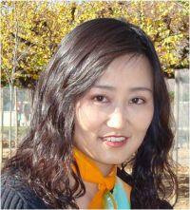

Dr. Hui Su is a senior scientist in the Jet Propulsion Laboratory (JPL), California Institute of Technology. She earned a B.Sc. in Atmospheric Dynamics in 1991 from Peking University; and a Ph.D. in Atmospheric Sciences in 1998 from the University of Washington. Prior to working at the Jet Propulsion Laboratory in 2005, she worked as a Staff Research Associate and Assistant Researcher at the University of California, Los Angeles. Dr. Su received the JPL Lew Allen Award for Excellence in 2008 and NASA Exceptional Scientific Achievement Medal in 2010 for "major advances in the understanding of water vapor and cloud feedbacks on climate change through quantitative analysis of observations from multiple NASA satellites." Her research interest is primarily in climate dynamics and convective processes. She is a member of NASA Aura and NEWS science team and the Principal Investigator for a number of NASA funded projects. Dr. Su has been an Assistant Director of the UCLA Joint Institute for Regional Earth System Science and Engineering (JIFRESSE) since January 2015. She served as the 2015 Chinese-American Engineers and Scientists Association of Southern California (CESASC) Technical Symposium Chair and is the President of the Executive Committee of the Chinese -American Oceanic and Atmospheric Association - Southern California Chapter (COAA SCC) in 2015-2016.

**Peter Zhang, Ph.D.*（*章華*）***

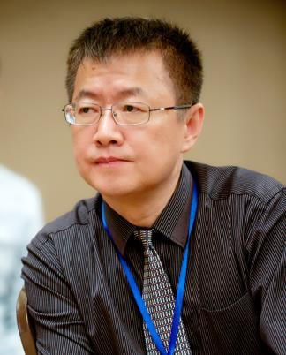

Dr. Peter Zhang has served as a board member of CESASC since earlier 2013 and is in charge of design and maintenance of the CESASC website and Scholarship award. He currently works as an independent consultant at ZHTECH Corporation. Throughout his career, Dr. Peter Zhang has served in different roles, including senior IT consultant, IT director, program and project manager, software engineer, hydrogeologist, and geochemist in government agencies, Fortune 100 companies, and his own consulting firm (www.zhtech.com). His recent work and research focus on Cloud computing, Big Data, business intelligence, and distance learning. He is also an adjunct professor in the computer science department at Cal State University, Fullerton. He has created an e-learning organization called ZHTECH Academy (www.zhtech.org) and is an active faculty in the academy. Dr. Zhang graduated from the University of Minnesota with MS and Capella University with Ph.D.

**Jia Fan (范佳)**

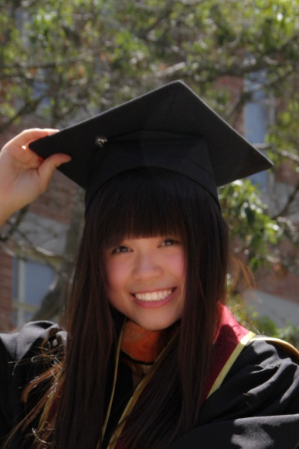

Ms. Jia Fan is a project engineer at Eva Care Group, LLC. She is in charge of environmental compliance and construction management for projects of senior health care centers. Her interests are construction budgeting & estimating, scheduling and quality control. Ms. Fan has been LEED Accredited Professional since 2013. She has expertise in the fields of green building design, especially in water efficiency and indoor environmental quality. Prior to joining Eva Care Group, Ms. Fan worked as a scientific aid in Groundwater Unit at Los Angeles Water Quality Control Board. She has assisted in managing wide variety of groundwater and soil contamination cases with pollutants of VOC, metals, etc.. Ms. Fan received her Bachelor of Science in Environmental Science from Donghua University, China and Masters of Science in Environmental Engineering from University of Southern California. In the field of her professionals, Ms. Fan is energetic and courageous to explore; in the field of social events and commonweal, she is collaborative and eager to dedicate.

**Yang Yang, Ph.D. (楊陽)**

Professor Yang Yang holds a BS in Physics from the National Cheng-Kung University in Taiwan in 1982, and he received his M.S. and Ph.D. in Physics and Applied Physics from the University of Massachusetts, Lowell in 1988 and 1992, respectively. Before he joined UCLA in 1997, he was the research staff of UNIAX Corporation (now DuPont Display) in Santa Barbara from 1992 to 1996.

Professor Yang is the Carol and Lawrence E. Tannas Jr. Chair Professor of Materials Science and Engineering at UCLA. He is a materials physicist with expertise in the fields of organic electronics, organic/inorganic interface engineering, and the development and fabrication of related devices, such as photovoltaic cells, LEDs, and memory devices. His notable contributions to the field of organic photovoltaics (OPV) are enhanced understanding of polymer morphology and its influence on device performance; the invention of the inverted organic solar cell; the inverted tandem solar cell; and transparent OPV devices. Since 2007, he has taken the lead in the creation of several world record cells in OPV, with a recent efficiency of 10.6% - 11.6% PCE via tandem structure.

In addition to organic solar cells, his group is also heavily involved in the development of liquid-processable CIGS/CZTS photovoltaics. His group has achieved approximately 11.2% PCE using a CISS absorber layer deposited from a solution- phase precursor system. Recently, his group has entered the field of perovskite solar cell, and he demonstrated 19.3% power conversion efficiency by interface engineering and improved crystal growth process. Professor Yang has as published more than 290 peer-reviewed papers (including book chapters); ~60 patents (filed or issued), and given 150 invited talks. His H-Index is 115 as of January 2016.

Some of his recent honors and awards are:

Distinguised Achievement Award, CESASC, April 23, 2016.

'World's most influential scientific minds” by Thomason Reuters, 2016. (Only 19 scientists worldwide selected.)

Second highest cited papers in Chemistry between 2005 - 2015, selected by the American Chemical Society (ACS).

Highly Cited Researcher in Materials Science and Chemistry Categories (2016, 2015, 2014) published by Thomason Reuters.

Fellows of American Physical Society (2015); Materials Research Society (2015); Royal Society of Chemistry (2015); SPIE (2014) and the E-M Academy (2014).

The Carol and Lawrence E. Tannas Jr. Endowed Chair in Engineering, 2011.

**Wanwan Yang, Ph.D. (楊婉婉)**

Dr. Wanwan Yang is currently the Chief Investment Officer of HUAQI Capital, a life science investment company based in Irvine, California. Prior to HUAQI, She served as the director of Sales & Marketing at BioOptions, a biorepository company that provides bio-specimens to other pharmaceutical & device companies to support their technology development. Before joining BioOptions, She was the VP of Research & Development at lmpeDx Diagnostics; a medical device company develops and markets a novel system for rapid detecting bacteria in blood culture specimens for use in clinical laboratories. Prior to lmpeDx Diagnostics, she worked in 0-Ray Pharmaceuticals, a startup company developing sustained release formulations to deliver drugs to the inner ear. Before working in the biotech industry, she was a postdoctoral scholar/lab manager at the Jet Propulsion Laboratory.

Wanwan also was a presenter of technical symposium at 2015 CESASC Convention.

Wanwan received her Ph.D. in environmental microbiology from Caltech in 2009, and BS. in Chemical Engineering from Tsinghua University in 2001.